Day 29 - 21st Aug 2025

Dynamo DB | Overview of AWS DynamoDB, Terminology Comparison with SQL, DynamoDB Tables and Naming,Conventions, Data, DynamoDB Consistency Model, DynamoDB Capacity Units, DynamoDB On Demand Capacity, Basics of DynamoDB Partitions, Basics of DynamoDB Indexes, Local Secondary Indexes and Global Secondary Indexes
Working with DynamoDB using AWS Console3 | Interacting with DynamoDB -Table-level Operations with AWS Console, Item-level Operations with AWS Console, Additional Features in DynamoDB Console
Working with DynamoDB using AWS CL | Working with the AWS CLI, Table level Operations with AWS CLI, Write Operations - Item level Operations with AWS CLI, Read Operations - Item level Operations with AWS CLI
Working with DynamoDB using AWS SDK | Working with DynamoDB using AWS SDK - Introduction, Table-level Operations with AWS SDK, Write Operations - Item Level Operations with AWS SDK, Conditional Writes - Item Level Operations with AWS SDK, Atomic Counters - Item Level Operations with AWS SDK, Read Operations - Item Level Operations with AWS SDK, Paginated Reads - Item Level Operations with AWS SDK
DynamoDB Data Modeling & Best Practices | DynamoDB Architecture, DynamoDB Partitions in Depth, DynamoDB Efficient Key Design, Hot Keys or Hot Partitions, DynamoDB Design Patterns, Multi-value Sorts and Filters, DynamoDB Limits - Error Handling in DynamoDB, Ways to Lower DynamoDB Costs

https://docs.aws.amazon.com/amazondynamodb/latest/developerguide/workbench.settingup.html
Download NoSQL Workbench for DynamoDB - Amazon DynamoDB
Download the official version of NoSQL Workbench for Amazon DynamoDB. With NoSQL Workbench, you can model schemas, visualize data, and query tables before pushing it all to DynamoDB.

https://docs.aws.amazon.com/amazondynamodb/latest/developerguide/workbench.settingup.install.html
Install NoSQL Workbench for DynamoDB - Amazon DynamoDB
Install the official version of NoSQL Workbench for Amazon DynamoDB. With NoSQL Workbench, you can model schemas, visualize data, and query tables before pushing it all to DynamoDB.

Task 1:

Create a data model -ATLAS Batch1
Add a table - MyBatch
Attributes - id, Empid, f name, l name, city, ph no

12.10 to 12.15

Aws cli download for windows — link pasted…

https://docs.aws.amazon.com/cli/latest/userguide/getting-started-install.html

After installing

Open cmd

Type aws - -version (no space after -)
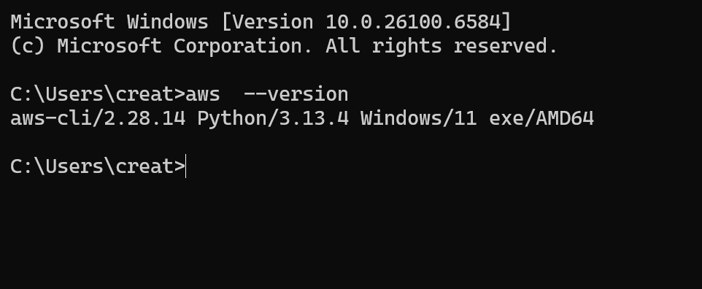

Create table.java
package com.example;

import java.util.Arrays;

import com.amazonaws.services.dynamodbv2.AmazonDynamoDB;
import com.amazonaws.services.dynamodbv2.AmazonDynamoDBClientBuilder;
import com.amazonaws.services.dynamodbv2.document.DynamoDB;
import com.amazonaws.services.dynamodbv2.document.Table;
import com.amazonaws.services.dynamodbv2.model.AttributeDefinition;
import com.amazonaws.services.dynamodbv2.model.KeySchemaElement;
import com.amazonaws.services.dynamodbv2.model.KeyType;
import com.amazonaws.services.dynamodbv2.model.ProvisionedThroughput;
import com.amazonaws.services.dynamodbv2.model.ScalarAttributeType;

public class Createtable {
public static void main(String[] args) {
// Use local DynamoDB endpoint
AmazonDynamoDB client = AmazonDynamoDBClientBuilder.standard()
.withEndpointConfiguration(
new com.amazonaws.client.builder.AwsClientBuilder.EndpointConfiguration(
"http://localhost:8000", "us-west-2"))
.build();

DynamoDB dynamoDB = new DynamoDB(client);
String tableName = "Employee01";

try {
Table table = dynamoDB.createTable(
tableName,
Arrays.asList(new KeySchemaElement("ID", KeyType.HASH),
new KeySchemaElement("No", KeyType.RANGE)),
Arrays.asList(new AttributeDefinition("ID", ScalarAttributeType.N),
new AttributeDefinition("No", ScalarAttributeType.S)),
new ProvisionedThroughput(5L, 5L));

table.waitForActive();
System.out.println("Table created successfully: " + table.getDescription().getTableStatus());
} catch (Exception ex) {
System.err.println("Error creating table: " + ex.getMessage());
}
}
}

Table loading data.java
package com.example;

import java.io.File;
import java.util.Iterator;

import com.amazonaws.auth.AWSStaticCredentialsProvider;
import com.amazonaws.auth.BasicAWSCredentials;
import com.amazonaws.client.builder.AwsClientBuilder;
import com.amazonaws.services.dynamodbv2.AmazonDynamoDB;
import com.amazonaws.services.dynamodbv2.AmazonDynamoDBClientBuilder;
import com.amazonaws.services.dynamodbv2.document.DynamoDB;
import com.amazonaws.services.dynamodbv2.document.Table;
import com.amazonaws.services.dynamodbv2.document.Item;
import com.fasterxml.jackson.core.JsonFactory;
import com.fasterxml.jackson.core.JsonParser;
import com.fasterxml.jackson.databind.JsonNode;
import com.fasterxml.jackson.databind.ObjectMapper;
import com.fasterxml.jackson.databind.node.ObjectNode;

public class EmployeeLoadingData {
public static void main(String[] args) throws Exception {

// DynamoDB client (Local DynamoDB on port 8000)
AmazonDynamoDB client = AmazonDynamoDBClientBuilder.standard()
.withEndpointConfiguration(
new AwsClientBuilder.EndpointConfiguration("http://localhost:8000", "us-west-2"))
.withCredentials(new AWSStaticCredentialsProvider(
new BasicAWSCredentials("dummyKey", "dummySecret")))
.build();

DynamoDB dynamoDB = new DynamoDB(client);
Table table = dynamoDB.getTable("Employee01");

// absolute path for Employee.json
File file = new File("C:\\Users\\creat\\Desktop\\Backup\\Day29\\demo001\\src\\main\\resources\\Employee.json");

if (!file.exists()) {
System.err.println("JSON file not found at: " + file.getAbsolutePath());
return;
}

// Parse JSON file
JsonParser parser = new JsonFactory().createParser(file);
JsonNode rootNode = new ObjectMapper().readTree(parser);

Iterator<JsonNode> iterator = rootNode.iterator();
while (iterator.hasNext()) {
ObjectNode currentNode = (ObjectNode) iterator.next();
int ID = currentNode.path("ID").asInt();
String nomenClature = currentNode.path("NomenClature").asText();

// Additional attributes from JSON
String name = currentNode.path("Name").asText(null);
int age = currentNode.path("Age").asInt(0);
String location = currentNode.path("Location").asText(null);

try {
table.putItem(new Item()
.withPrimaryKey("ID", ID, "No", nomenClature)
.withString("Name", name)
.withNumber("Age", age)
.withString("Location", location));

System.out.println("Inserted: " + ID + " - " + nomenClature + " - " + name);
} catch (Exception ex) {
System.err.println("Error inserting item: " + ex.getMessage());
}
}
parser.close();

System.out.println("Data load completed!");
}
}

Employee.json

[
{
"ID": 1001,
"NomenClature": "EMP1001",
"Name": "Ajay",
"Age": 30,
"Location": "Delhi"
},
{
"ID": 1002,
"NomenClature": "EMP1002",
"Name": "Kumar",
"Age": 25,
"Location": "Hyd"
},
{
"ID": 1003,
"NomenClature": "EMP1002",
"Name": "Kadiyala",
"Age": 22,
"Location": "Hyd"
}
]

Info Box:

Updated Excalidraw link till Day 28th

SUDIPTO (Guest): https://excalidraw.com/#json=xvNUDQ1IwmQtNRFUjagCk,QaLSI7nJet4POU...
sent on 21 August 2025 10:04

Excalidraw updated at 10.35 21st Aug 2025
https://excalidraw.com/#json=OQ4rEVI5vj4ZpLTGqjgE8,cPKJbB12sGieNoTUtb95Bg

https://excalidraw.com/#json=CS_5sAXd_aDXxFJ3EzCxc,6jR_JuRbifYV9EgZS7iOUw

Excalidraw updated at 18.47

https://excalidraw.com/#json=dsW9SpX2U2F3zFSddxncW,1dYkx_4-FoXesozm3d-AuA

